Article Heading
Abstract
Lorem ipsum dolor sit amet, consectetur adipiscing elit, sed do eiusmod tempor incididunt ut labore et dolore magna aliqua. Ut enim ad minim veniam, quis nostrud exercitation ullamco laboris nisi ut aliquip ex ea commodo consequat. Duis aute irure dolor in reprehenderit in voluptate velit esse cillum dolore eu fugiat nulla pariatur. Excepteur sint occaecat cupidatat non proident, sunt in culpa qui officia deserunt mollit anim id est laborum.
Keywords
Keyword 1, keyword, 2 keyword 3, keyword 4, keyword 5
1.0 Introduction
1.1 Article Heading Level 2
1.1.1 Article heading level 3
1.1.1.1 Article heading level 4
2.0 Materials and Methods

3.0 Results and Discussion
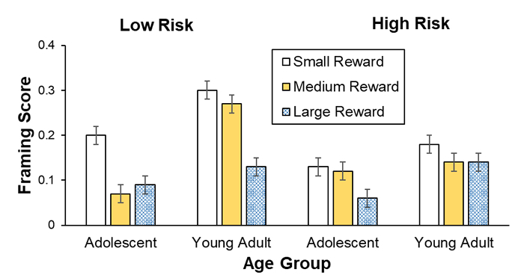
Figure 1:Name of figure goes here

Table 1: Title of table goes here
Data A | Data B | Data C | Data D | Data E
Blue | 1.34 | 0.456
Green | 1.45 | 0.532
White | 6.00 | 0.643
Yellow | 7.34 | 0.632
Brown | 23.53 | 0.963
Orange | 67.34 | 0.030

4.0 ConclusionS and recommendation

5.0 References
The “Science” Citation style referencing should be used. Detailed description on how to use the citation format is shown below.
- Click here to download Endnote citation
- Click here to download Mendeley/Zotero Science Citation Style
6.0 Acknowledgements (if available)

Science Citation Style
In-text citation
In-text references should be cited in parentheses by their corresponding number (#). Multiple reference citations are separated by commas (#, #). When citing more than two consecutive references, use an en dash (#–#).
Examples:
A recent study points to growth of textile industry (1).
Clay refractories are mor popular (2, 3).
cats are friendlier (4–6).
General comments
Author names: Use initials first for all authors, (separated by a space) for given names; spell out family names in full. Use commas (not “and”) to separate author names. Do not use punctuation before name suffixes (e.g., Jr., 3rd, III).
Journal articles
Titles of cited articles should be included, followed by a period. Journal titles should be in italics; volume numbers should be in bold. (If there is no volume number, use the publication year in its place.) Do not place a comma before the volume number or before any parentheses. Provide the full-page range, with numbers separated by an en dash. If the publication does not have continuous page numbers, use the article number (or citation number) instead of the page range. Indicate the publication year in parentheses. End each listing with a period. Do not use “ibid.” or “op. cit.”
Examples
1. A. B. Author, C. D. Author, Example article title. Example Journal Name 55, 100–108 (2021).
[with page range]
2. A. B. Author, C. D. Author, Example article title. Example Journal Name 346, e12345 (2022).
[with article number instead of page range]
3. A. B. Author, C. D. Author, Example article title. Example Journal Name 17 (suppl. 1), 62–66 (2020).
[with supplement number]
4. S. Author, M. Author, H. Author, Example article title. Example Journal Name DOI (2022).
[early online publication/epub ahead of print (use DOI instead of volume and page/article numbers)]

Whole books
For edited books, insert the editor name(s), followed by “Ed.,” or “Eds.,” before the title. Italicize the book title and use “title case” (see examples below). After the title, provide (in parentheses) the publisher name, edition number (if any), and year.
Examples
1. G. Y. Author, Example Book Title (Publisher, 2022).
[basic example]
2. X. Editor, Y. Z. Editor, Q. Editor, Eds., Example Book Title (Publisher, 2021).
[with editors rather than authors]
3. M. Author, T. Author, Example Book Title (Publisher, ed. 3, 2022).
[with edition number]
4. Organization Name, Example Book Title (Organization Name, 2021).
[organization as both author and publisher]
Book chapters
Style is as above (for whole books), except that “in” appears before the title, and the names of the editors appear after the title. The chapter title may be provided before the book title; enclose chapter titles in quotes and use initial caps. After the information in parentheses, provide the complete page number range (and/or chapter number) of the cited material.
Examples
1. A. Author, Z. Author, “Optional: Example chapter title” in Example Book Title (Publisher, 2022), pp. 300–350.
[with chapter title]
2. T. D. Author, U. R. Author, in Example Book Title, F. Editor, Ed. (Publisher, 2021), pp. 37–71.
[with editor]

Books in series
If the book is part of a series, indicate the series title after the book title. The volume number is optional.
Examples
1. A. Author, B. Author, Example Book Title, vol. 5 of Example Series Title (Publisher, 2022).
Technical reports and monographs
The title should be in quotes and should have initial caps. After the title, provide the following in parentheses: report number (if applicable), publisher name, and year. A URL may be provided as well. Monographs in series may be treated as journals.
Examples
1. G. B. Author, “Example report title” (Tech. Rep. ABCD-12-34, Publisher, 2022).
[with report number]
2. F. Author, “Example report title” (Publisher, 2020); URL.
[with URL]
3. “Example report title” (Tech. Rep. 83902, Publisher, 2021).
[no author]
Meetings, conferences, and proceedings
If published, style is same as for book references. If unpublished, include the title of meeting, location, date(s), and sponsoring organization (if not part of the meeting name). Abstracts may be cited by abstract number (if applicable).
Examples
1. A. Author, X. Author, G. Author, in Proceedings of the 2019 Example Conference on Interesting Topic (Publisher, 2022), pp. 6645–6649.
[published]
2. A. Z. Author, “Example conference paper” in Proceedings of the 2021 Example Conference on Interesting Topic (Publisher, 2021), abstr. 875.
[published, paper title and abstract number provided]
3. M. Author, paper presented at the 25th Annual Meeting of Example Organization, Washington, DC, 10 to 13 October 2022.
[unpublished]
Theses
Name the university but not the degree. Name the city if the university could be mistaken for another. It is optional to include the thesis title.
Examples
1. B. Author, thesis, Example University (2021).
[no title]
2. R. Author, “Example title on an interesting topic,” thesis, Example University, Washington, DC (2020).
[with title and city]
Preprints
For arXiv, embed the URL in arXiv:identifier, but do not include the word “Preprint.” For bioRxiv and others, include “[Preprint]” after the article identifier, and insert the DOI (preferably in URL format) at the end.
Examples
1. J. V. Author, E. Author, D. F. Author, Example preprint title. arXiv:1111.12345 [category] (2021).
[arXiv]
2. D. Z. Author, K. Author, U. Author, M. R. Author, Example preprint title. bioRxiv 0123456 [Preprint] (2020). https://doi.org/10.1101/0123456.
[bioRxiv]
Datasets
List the version number, if applicable. Provide a DOI or other persistent identifier (preferably in URL format).
Example
1. D. Author, Example dataset title, version 1, Example Repository Name (2021); https://doi.org/10.12345/ABC1234567.
Software
Include the version number (if applicable). Provide a DOI (preferably in URL format) or other persistent identifier. If a persistent identifier does not exist, include a URL to where the software exists. If there is an article that describes the software, it should be cited in addition to the software itself. Do not cite the article instead of the software. A consensus guide to citing software, by a working group of multiple publishers, can be found here
Example
1. A. Author, B. Author, Example software title, version 2, Example Repository Name (2022); https://doi.org/10.12345/ABC000999.

